# CS 255 System Design Document Template

This template lays out all the different sections that you need to complete for Project Two. Each section has guidance to prompt your thinking. You will need to continually reference the interview transcript as you work to make sure that you are addressing your client’s needs. There is no required length for the final document. Instead the goal is to complete each section based on what your client’s needs are. Remove this note when you are finished, and replace all bracketed text with the relevant information.

## UML Diagrams

### UML Use Case Diagram

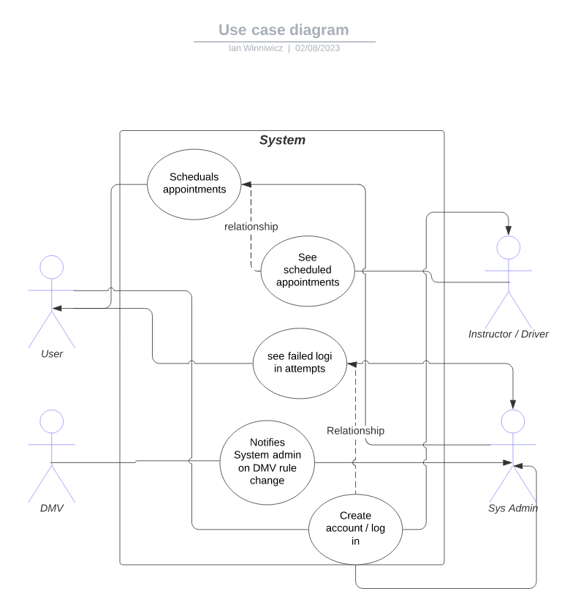

### UML Activity Diagrams

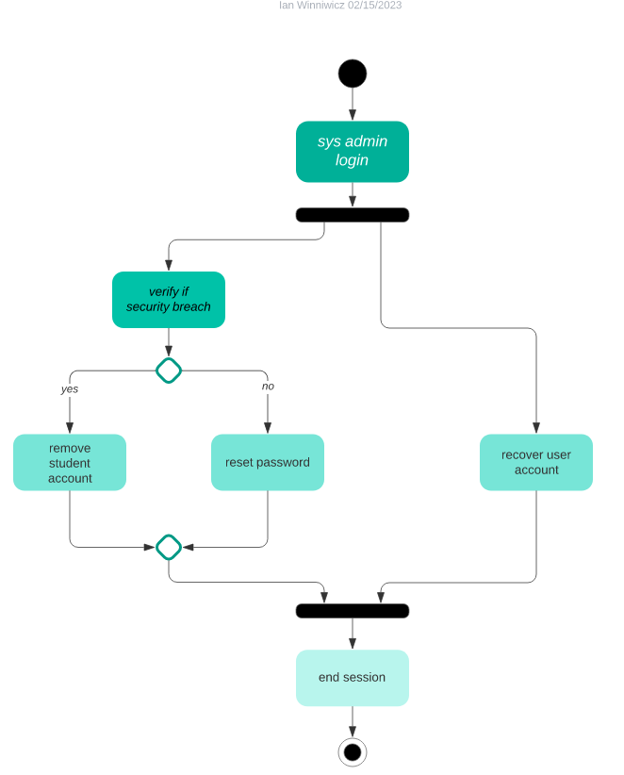

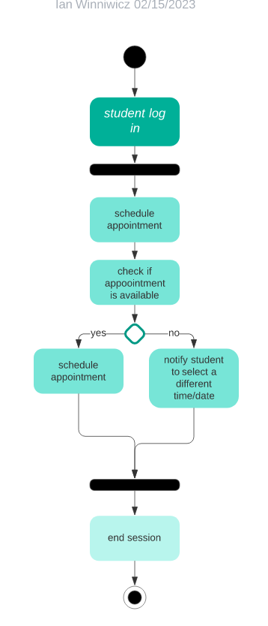

### UML Sequence Diagram

*[You were asked to create a sequence diagram based on* ***one*** *of the use cases you chose. Please insert your sequence diagram here. Check to make sure that you included appropriate components and symbols and that your design meets the client’s needs.]*

### UML Class Diagram

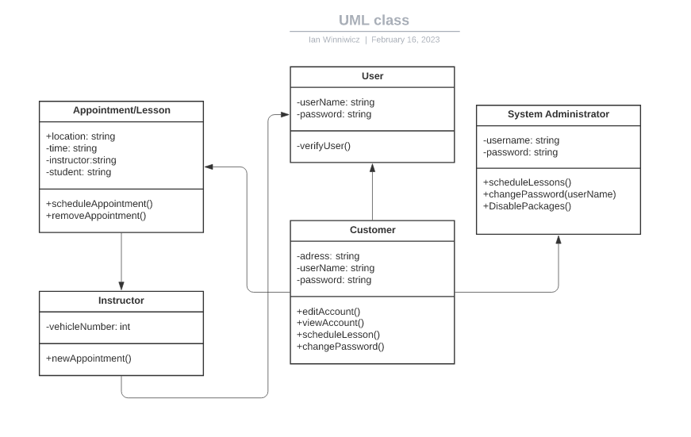

## Technical Requirements

Hardware Requirements include a server to store data, and an internet connection, desktop / laptop for the customer, they will also need an internet connection. The software is any operating system, the DriverPass software, cyber security software, and a browser. The tools needed are network administration tools, an internet connection, and programming software. The infrastructure required for this project is a physical server or cloud server hosting, and cars for the instructors.